**Advance Health Monitoring System  
ECG and Heart Rate Analysis for Early Detection and Diagnosis**

**Name : Ashutosh Rajendra karve**

**Bits-ID : 2024ht01021**

**Mail :** [**2024ht01021@wilp.bits-pilani.ac.in**](mailto:2024ht01021@wilp.bits-pilani.ac.in)

**Contact : +91 9765541324**

**Data : 14/09/2024**

**Place : Pune, Maharashtra**

**GUIDED FOR DETAILED UNDERSTANDING OF ECG AND WORKING:**

**Name : Dr. Prachi Pawar (BHMS)  
Reg No : (85206)   
Place : Pune, Maharashtra**

**Abstract:**

This project develops an advanced health monitoring system that uses the STM32 Blue Pill microcontroller and AD8232 ECG sensor to capture comprehensive cardiovascular data. The system is designed not only to monitor heart rate but also to detect critical conditions such as heart attacks, myocardial infarction, and electrolyte imbalances through sophisticated signal processing and diagnostic algorithms implemented in Python. Data captured in real-time is analyzed to identify abnormal rhythms and potential cardiovascular issues, providing detailed health reports within minutes.

**Introduction:**

The increasing prevalence of cardiovascular diseases globally necessitates the advancement of accessible and precise monitoring technologies. Our project integrates the STM32 Blue Pill with the AD8232 ECG sensor to create a portable, cost-effective solution for continuous cardiovascular monitoring. Leveraging advanced data processing techniques and artificial intelligence (AI), the system aims to offer predictive diagnostics and real-time health assessments, crucial for early intervention and management of heart-related conditions.

**Integration of Research Insights:**

Recent studies emphasize the integration of IoT and AI technologies to enhance the accuracy and predictive capabilities of ECG-based monitoring systems. For example, IoT technologies facilitate real-time data transmission and remote monitoring, while AI algorithms improve the accuracy of diagnosing complex cardiovascular conditions through pattern recognition and predictive analytics

The use of AI in ECG analysis has shown potential in detecting subtle and often overlooked signs of cardiac abnormalities, thus expanding the diagnostic capabilities beyond traditional methods

**System Design and Diagnostics:**

Our system design will now include modules for AI-driven data analysis to assess various health parameters indicated by ECG signals. The Python-based backend will implement machine learning models to analyze trends and irregular patterns, offering diagnostic insights into myocardial infarction, electrolyte imbalances, and more. This comprehensive approach ensures that the system not only monitors but also interprets cardiovascular signals to provide actionable health reports.

**Section 1: Hardware Integration**

**Step 1: Assembling the Hardware**

* **Components Required**:
  + STM32 Blue Pill microcontroller

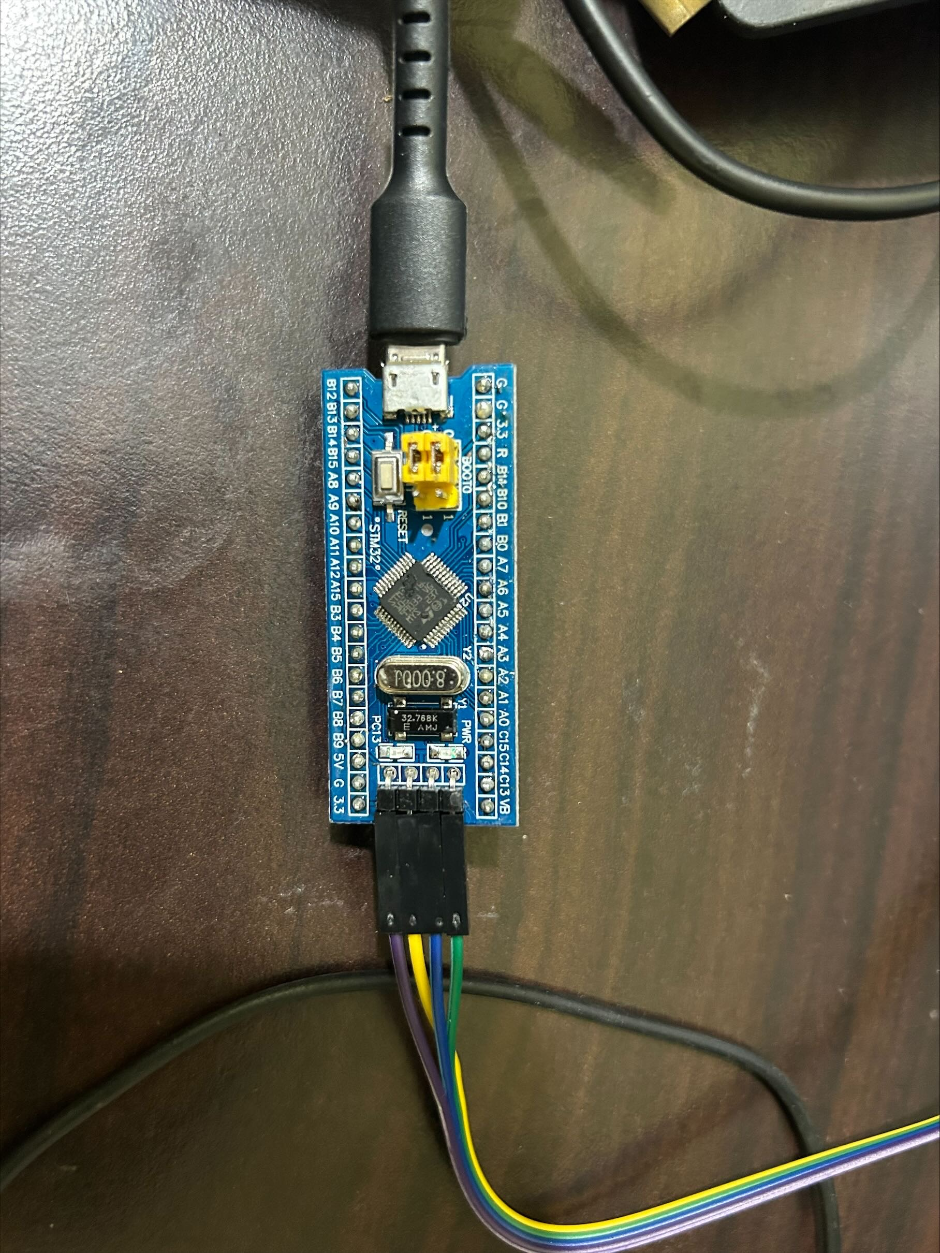

Microcontroller>>  
 Part : STM32F103C8T6  
 Manufacturer : ST-Microelectronics  
 Core : Arm Cortex-M3  
 Max. Clock : Speed 72MHz  
 Package : LQFP 48 pins

Internal memories>>  
 FLASH : 64KiB  
 SRAM : 20KiB

Oscillators>>  
 HSI : 8MHz  
 LSI : 40kHz  
 HSE : 8MHz  
 LSE : 32.768kHz

Power  
 Sources : Any +3.3V pin (+3.3V)  
 Any +5V pin (+5V)  
 USB connector (+5V)

* + USB cables & ST Link V2 for Programming

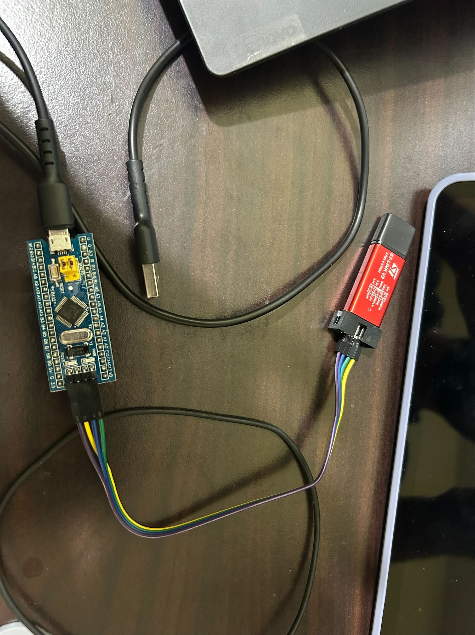

**Possible Connections**

To use a ST-Link to programme a blue/black pill (BP) under external  
power, connect it like this:

ST-Link GND (even-numbered pins from 4 to 20) to BP Ground  
ST-Link SWDIO (pin 7) to BP DIO  
ST-Link SWCLK (pin 9) to BP CLK  
ST-Link VAPP (pins 1 or 2) to BP 3V3

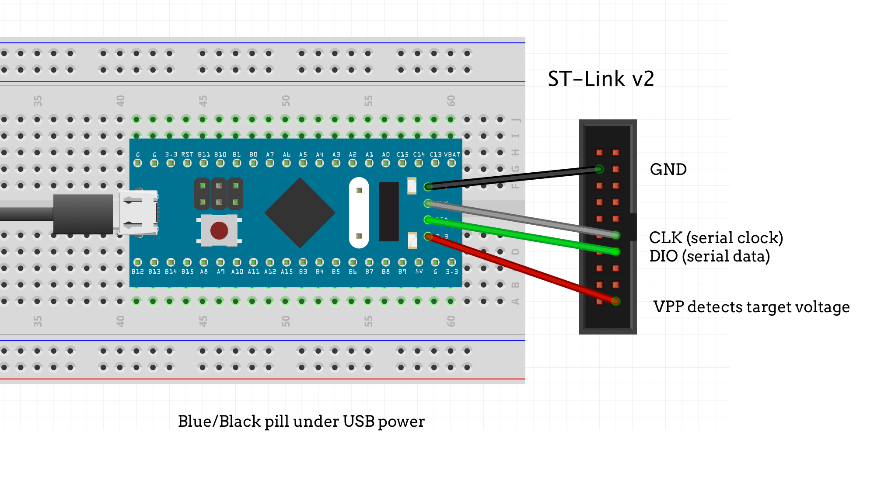

* + AD8232 ECG Sensor  
    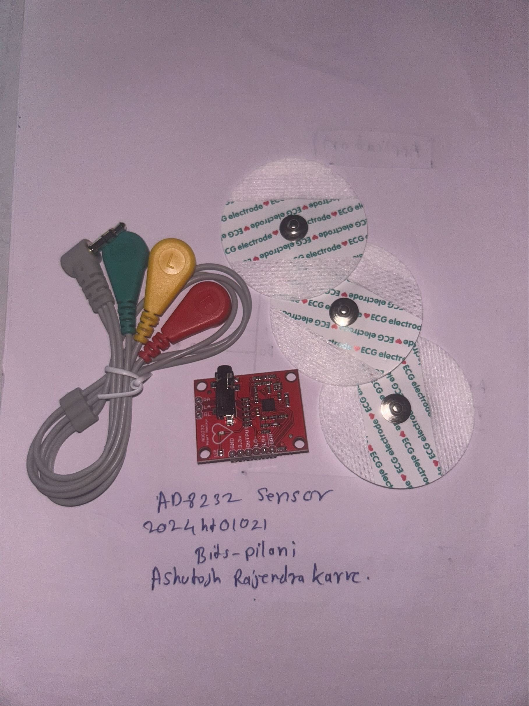
  + Heartbeat Pulse Sensor
  + Connecting wires
* **Procedure:**
  + **Power Connections**:
    - Connect the 3.3V and GND pins of the STM32 to the respective pins on the AD8232 and Heart Pulse Sensor.
  + **Signal Connections**:
    - Connect the OUTPUT of the AD8232 to PA0 on STM32 for ECG data capture.
    - Connect the OUTPUT of the Heart Pulse Sensor to PA1 on STM32 for heart rate measurement.
  + **USB Configuration**:
    - Ensure PA11 (USB_DM) and PA12 (USB_DP) are connected for USB functionality.
  + **Configuring Leads-Off Detection:**
    - Use PB0 and PB1 on STM32 to connect to LO- and LO+ on the AD8232 for detecting if the leads are properly attached.

**STM32 CUBE MX Pin Configuration:**

* **USB Configuration on STM32 Blue pill**I will use the STM32F103C8 controller in the USB DEVICE mode, and the Communication Device class (Virtual Com Port). The setup for the same is shown below screen shot

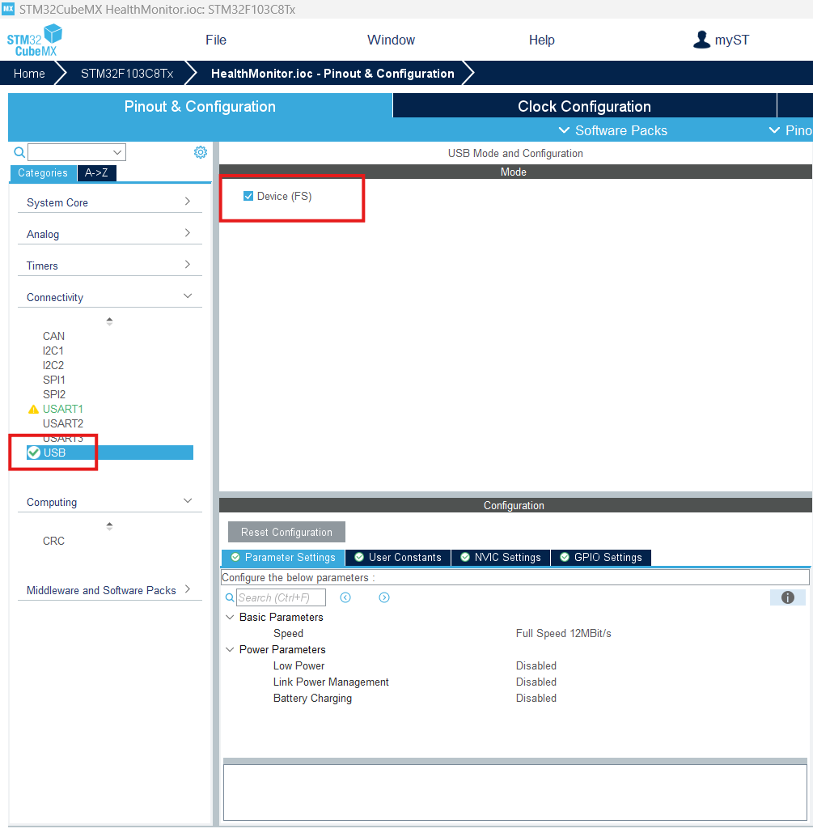First of all, I am selecting the USB in DEVICE only MODE, as shown above

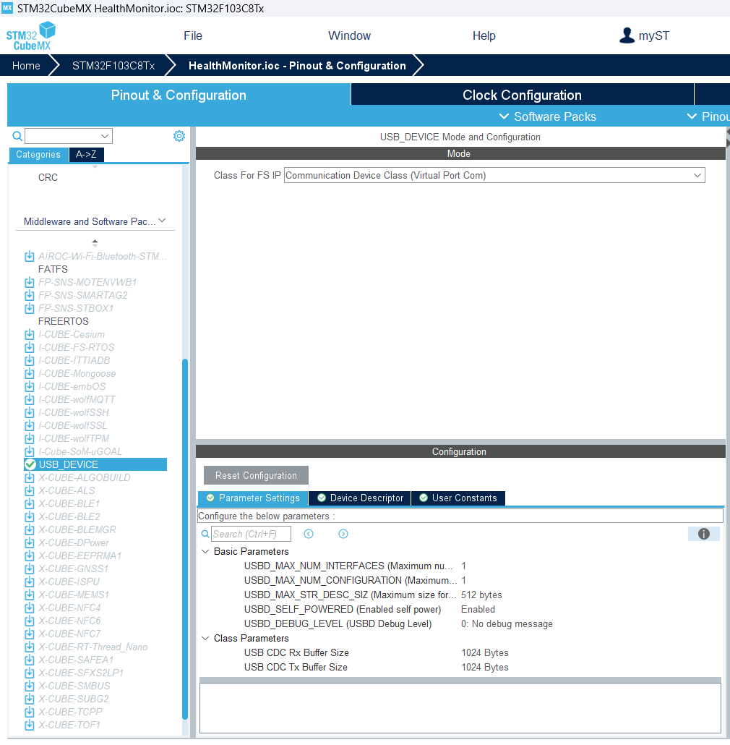  
in the USB Device, Select the class as Communication Device Class (Virtual Port Com)

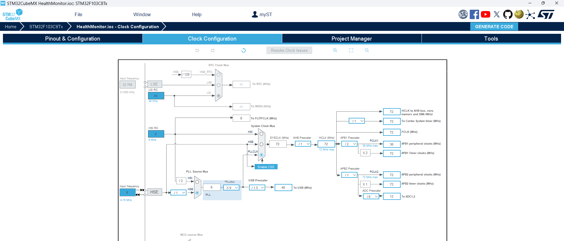

Finally, the clock is set to maximum here. As you can see above, the USB clock is automatically adjusted to 48 MHz

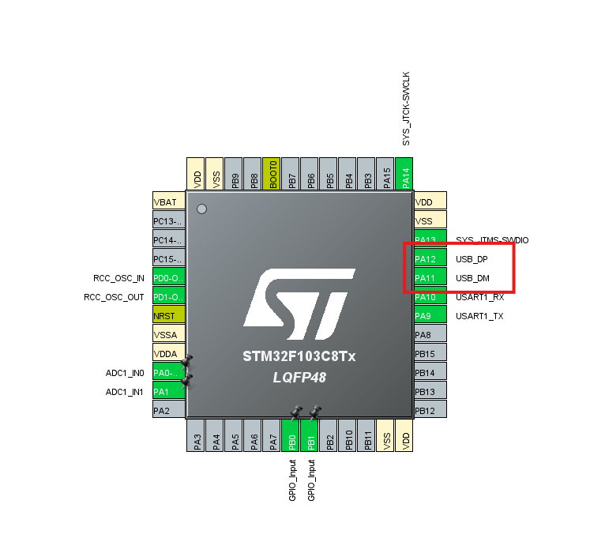  
Ensure PA11 (USB_DM) and PA12(USB_DP) are connected for USB functionality

**Sensor connection and configuration:**

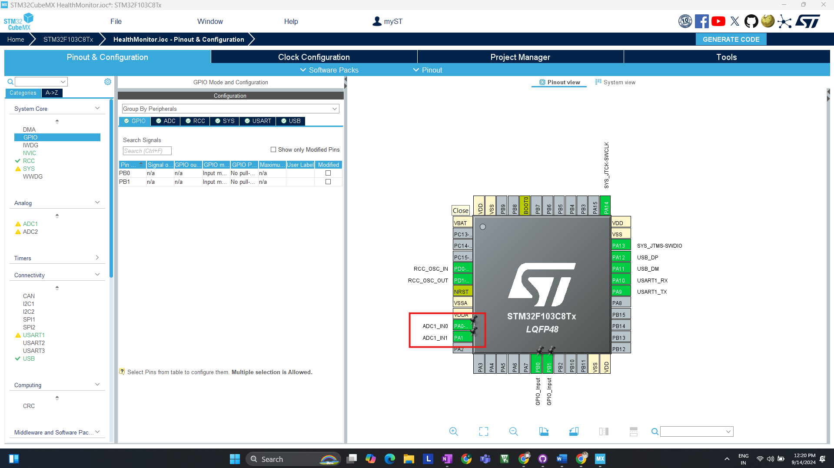

ADC Configuration is done for AD8283 & Heart Pulse detector sensor, AD8232 to **PA0** on STM32 for ECG data capture, Heart Pulse Sensor to **PA1** on STM32 for heart rate measurement.

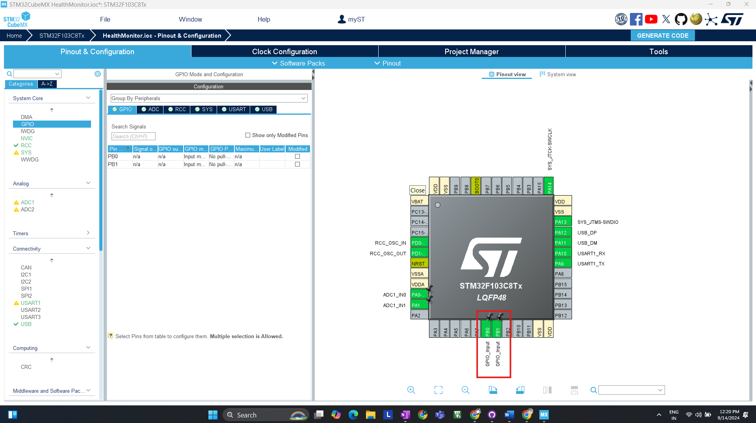Use PB0 and PB1 on STM32 to connect to LO- and LO+ on the AD8232 for detecting if leads are properly attached.

**Section 2: Initial Firmware Development & Testing STM32**

**Step 1: Environment Setup**

* **Tools Required:**
  + Keil V5 for programming and debugging.
* **Procedure:**
  + Install Keil V5 and configure the project for STM32F103C8Tx.
  + Set up project directories and necessary libraries (HAL, USB CDC).

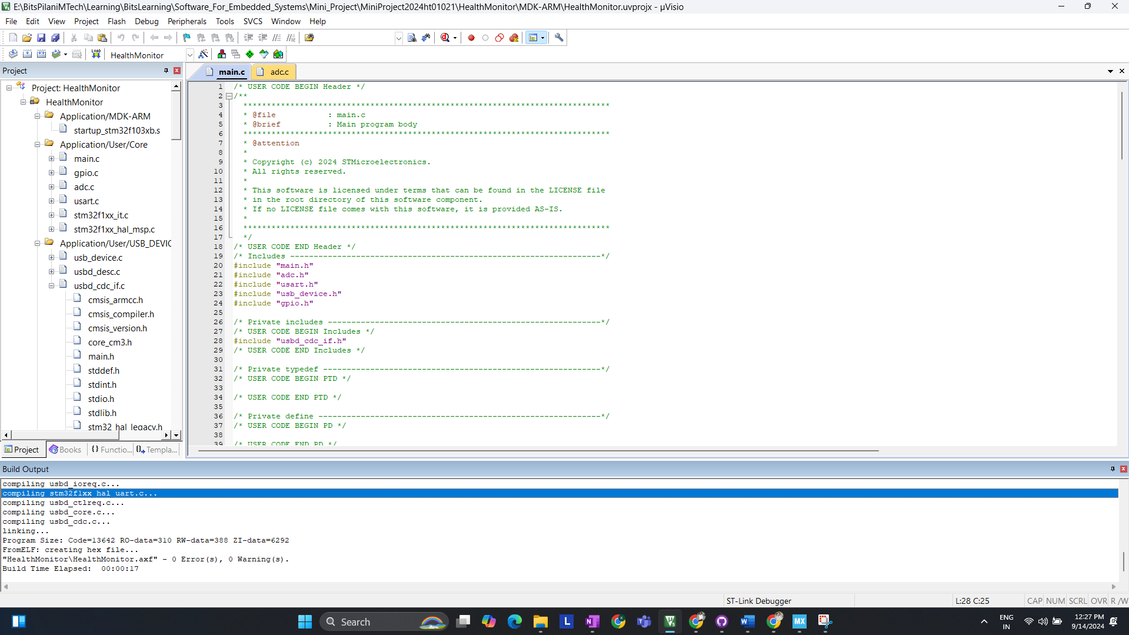  
  
Screen shot of error less code after generating code from STM32 Cube MX.

**Step 2: Coding**

* **Main Components**:

1. **USB Communication Setup**:  
   Implement USB CDC for data transmission to Ubuntu.

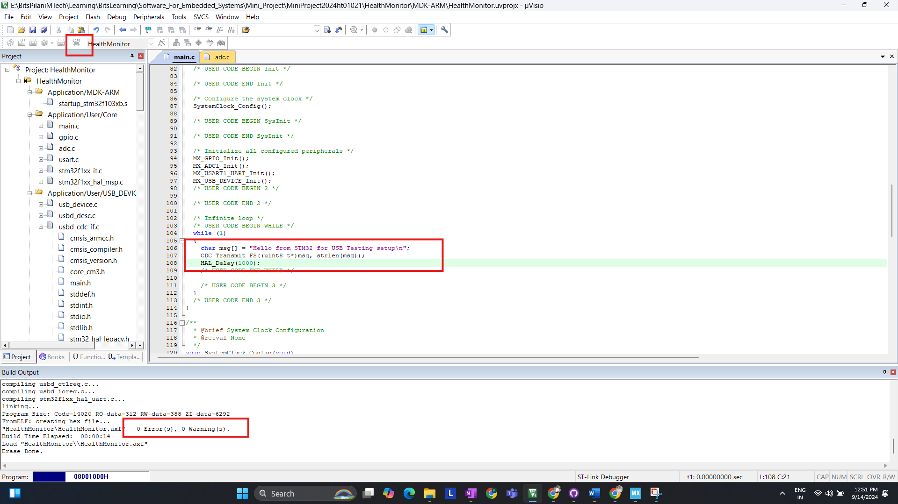  
In above screenshot I have compiled and flash code for USB CDC.  
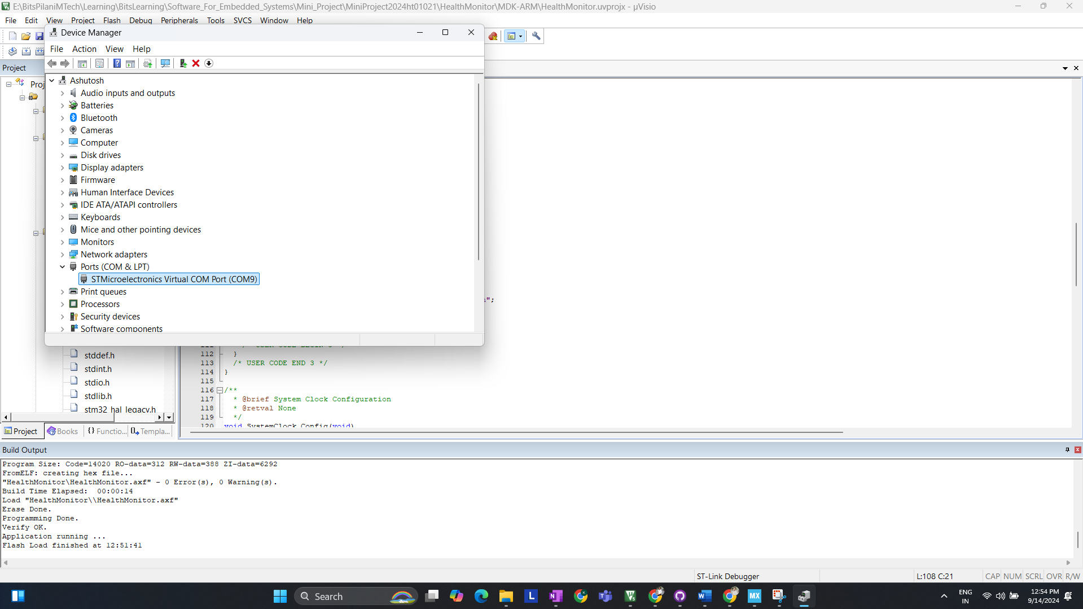  
We can detect COM Port (COM9) for Our device (STM32 Blue Pill)

**Checking with putty:**

Configuring Serial to COM9 and setting baud rate to 9600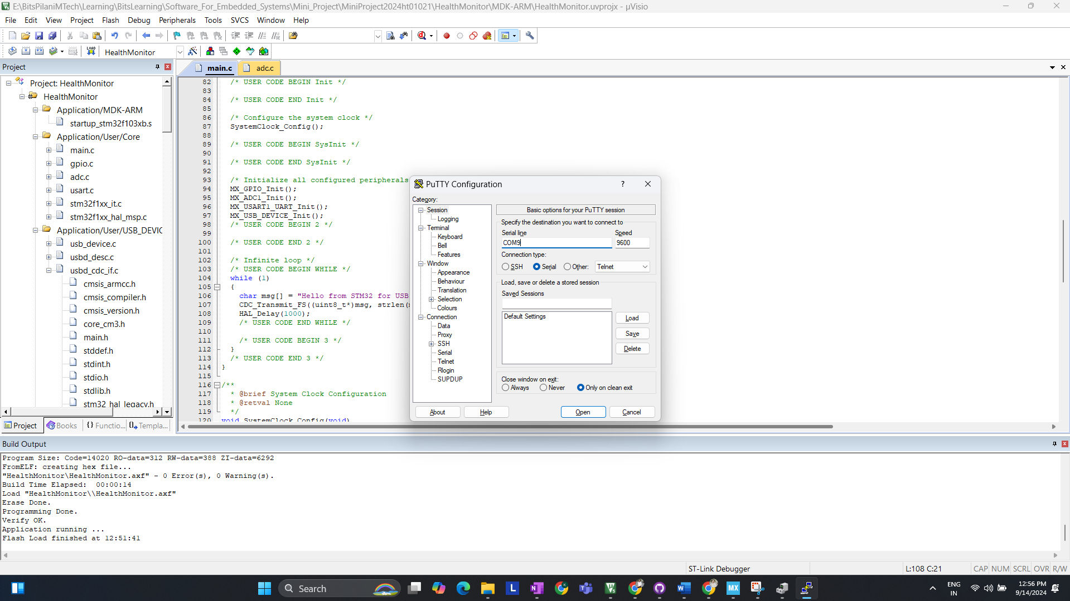  
Checking Serial Terminal We are receiving the DATA  
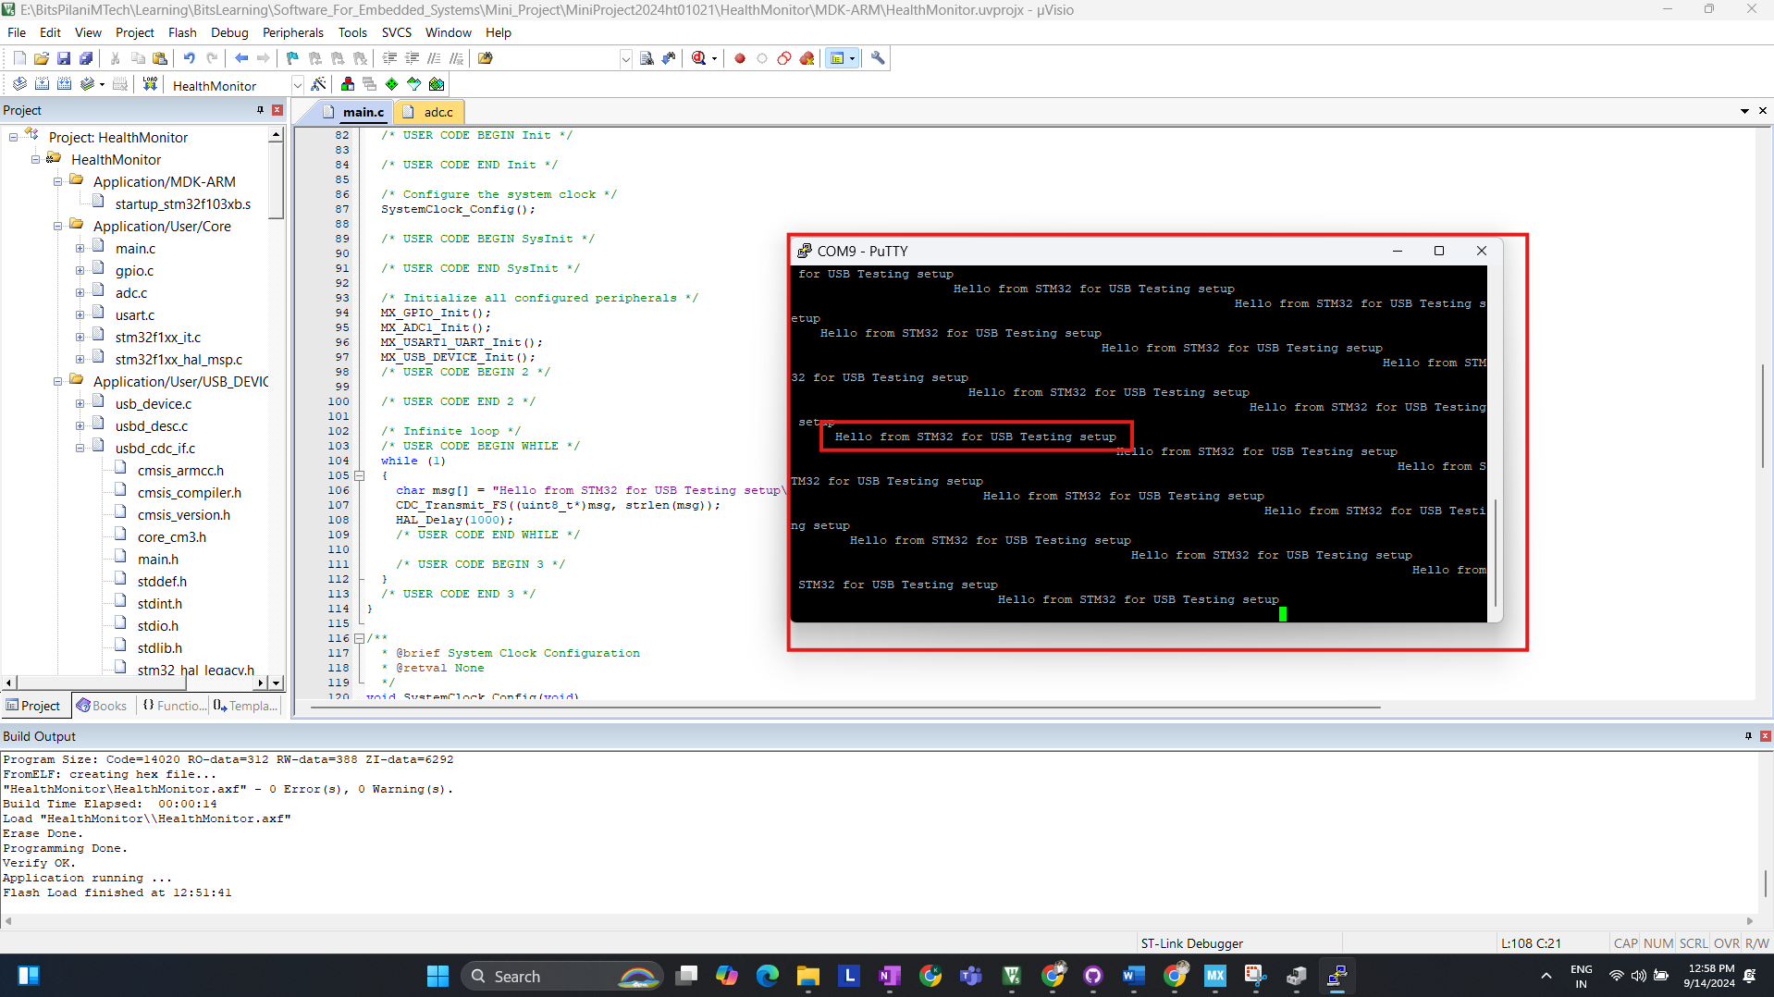

1. **ADC Configuration**:

The ADC is configured to read analog values from the ECG sensor connected to PA0 and the Heart Pulse sensor connected to PA1. The following code snippet demonstrates how to configure the ADC

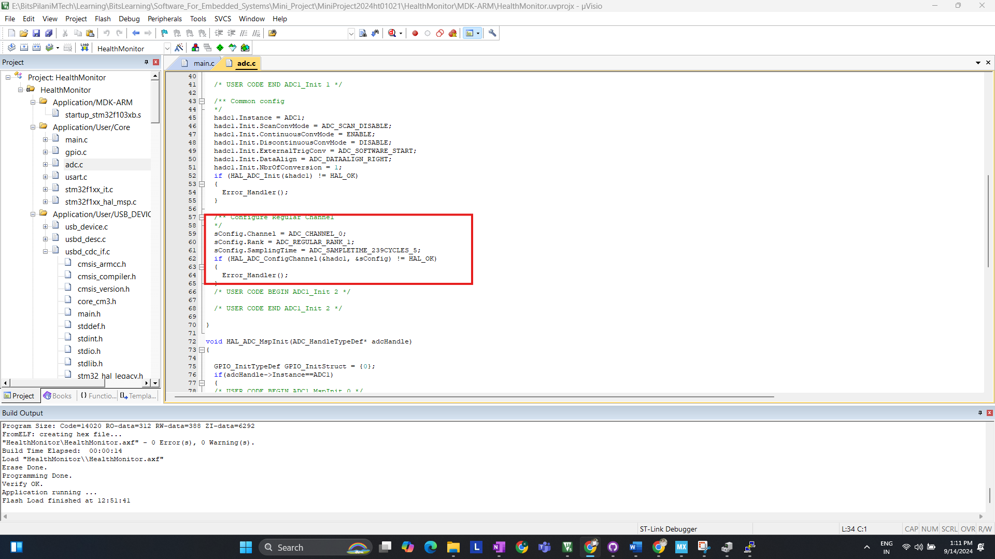

1. **Testing and debugging on Ubuntu**

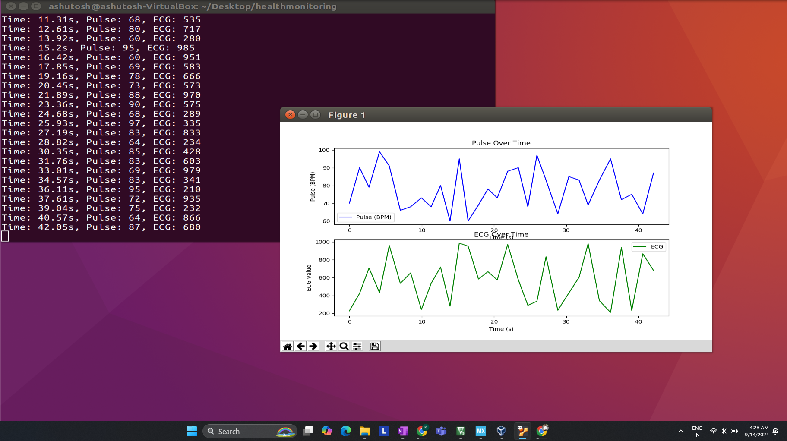  
Initial Fetching of RAW DATA for ECG and PULSE ON UBUNTU

**Section 4: Software Development on Ubuntu for Data Processing**

After completing the firmware development and testing the STM32's ability to transmit data via USB, the next step involves setting up the Python-based system on Ubuntu.

**Step 1: Setting Up the Python Environment**

**Tools Required:**

* Python 3.6 or higher
* Libraries:
  + **pyserial** for USB communication
  + **matplotlib** for visualizing ECG and pulse data
  + **numpy** for data handling and signal processing
  + **scipy** (optional) for more advanced signal processing and peak detection

**Step 2: Writing Python Code to Read Data from STM32**

The Python script will connect to the STM32 via the virtual COM port over USB, read the incoming data, and then process it. Below is a simple script to start reading the data. (Basic program to check connection with STM32 USB CDC)

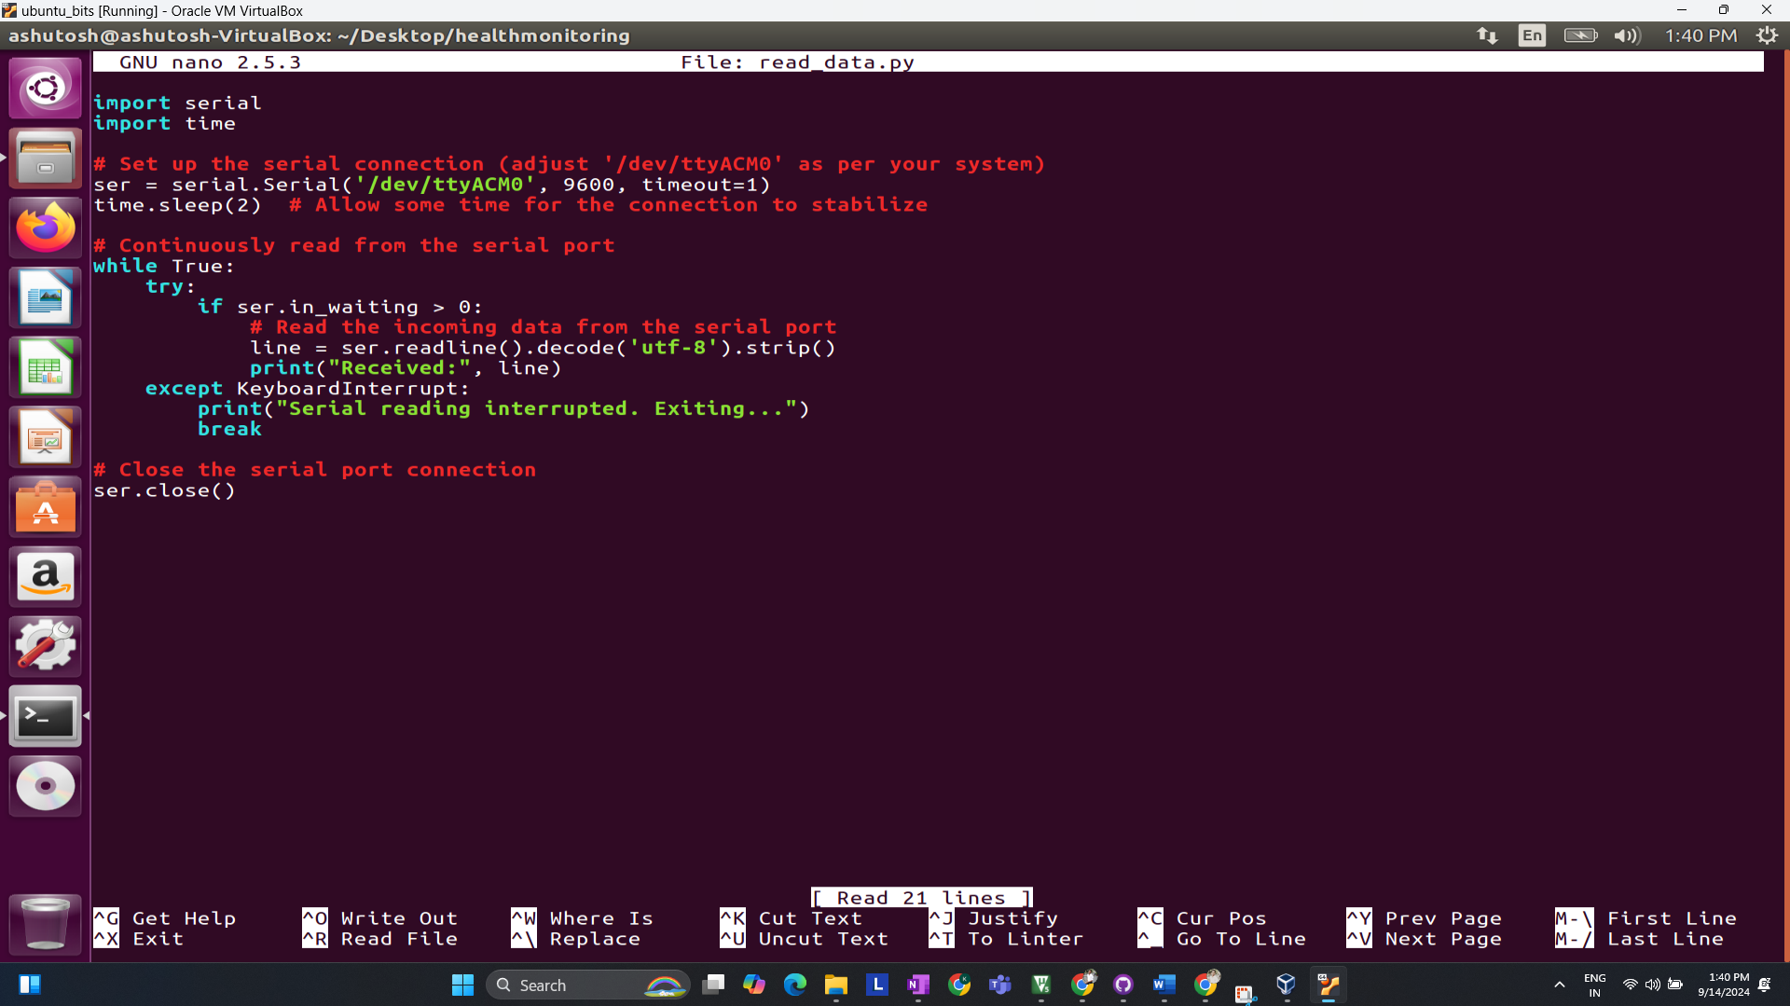

**Explanation**:

* The serial.Serial() function opens the USB serial port.
* The script reads incoming data from the STM32, which is sent every second, and prints it to the console.

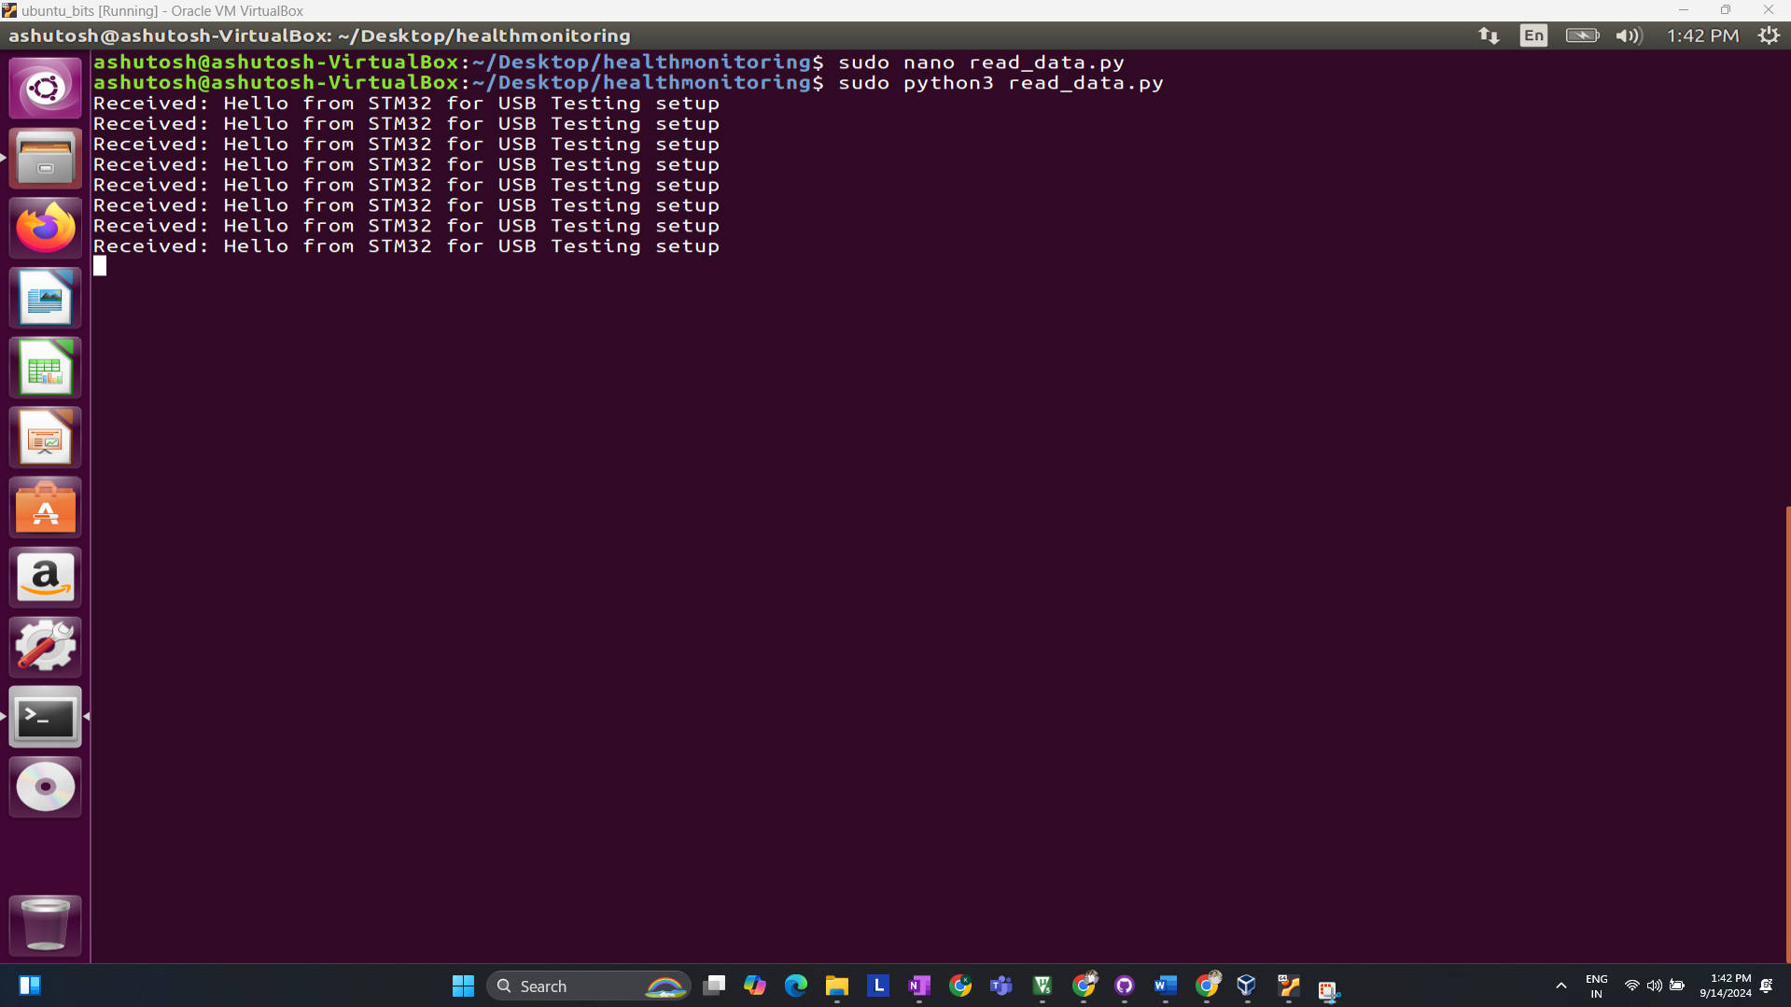

**Step 3: Visualizing the Data (Basic Visualization) (Testing)**

Once the data is received from STM32, it is important to visualize it. Using matplotlib, you can plot the ECG and heart pulse data in real-time.

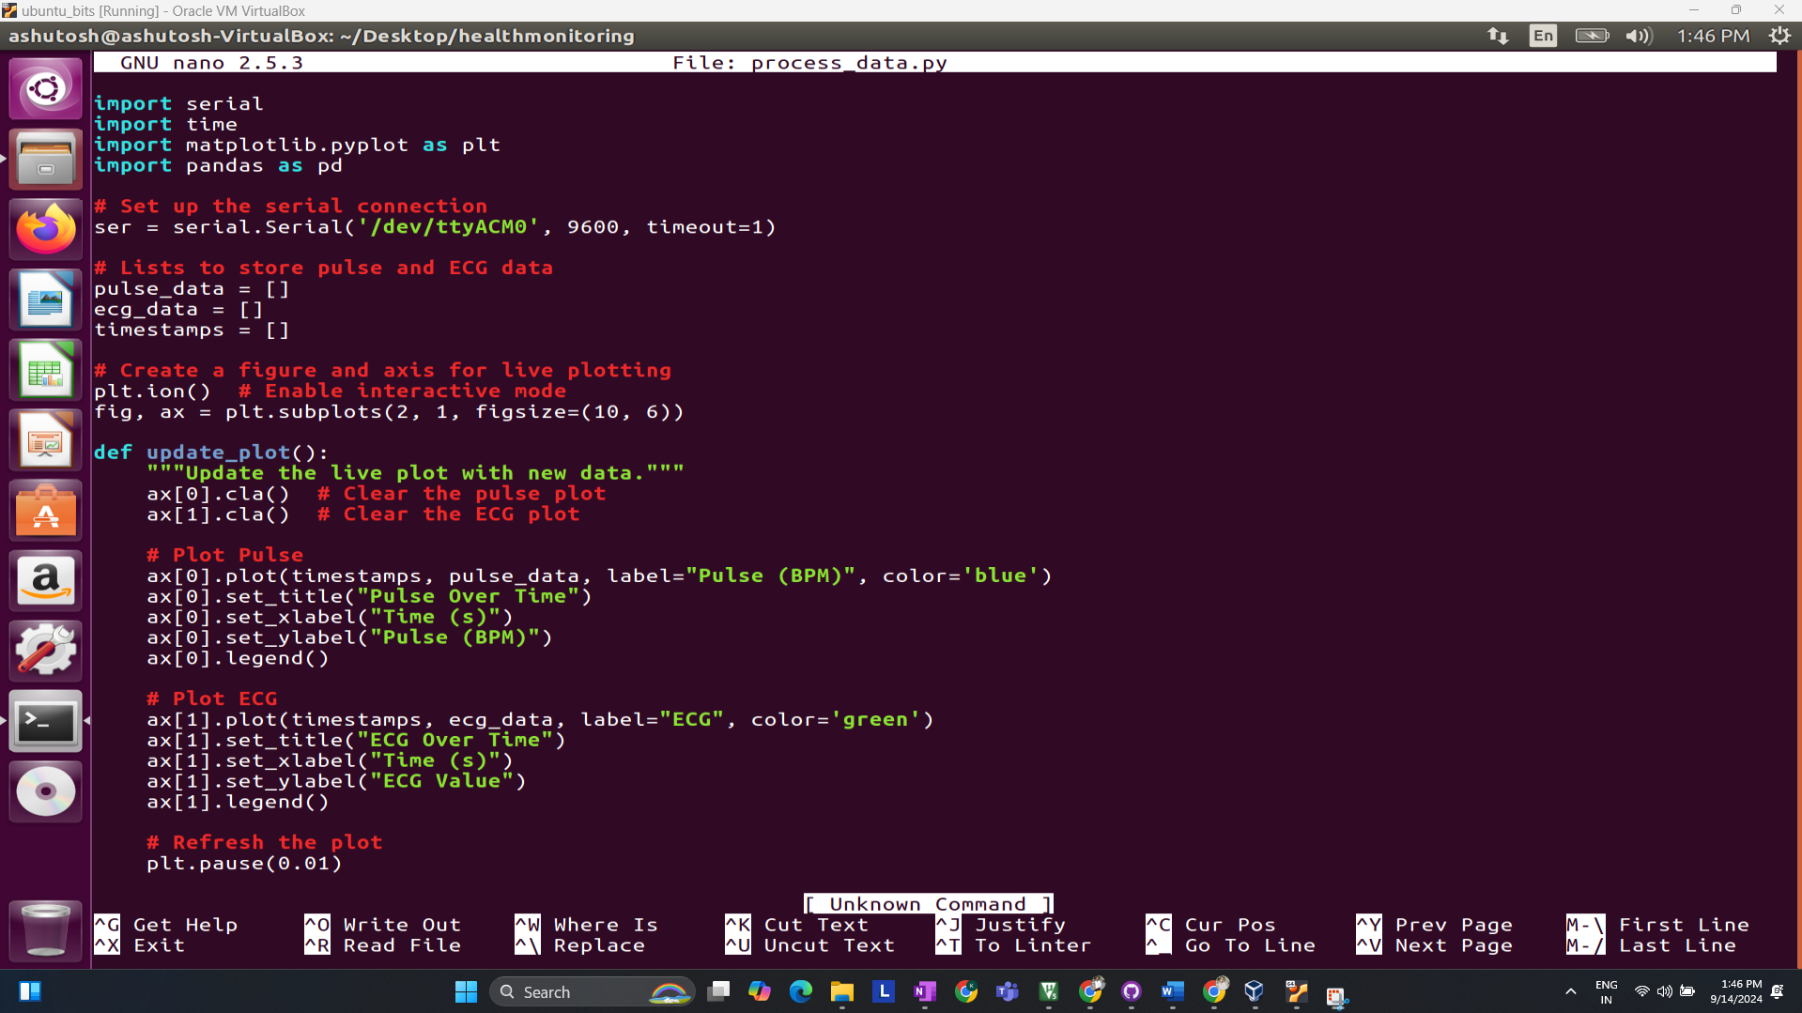

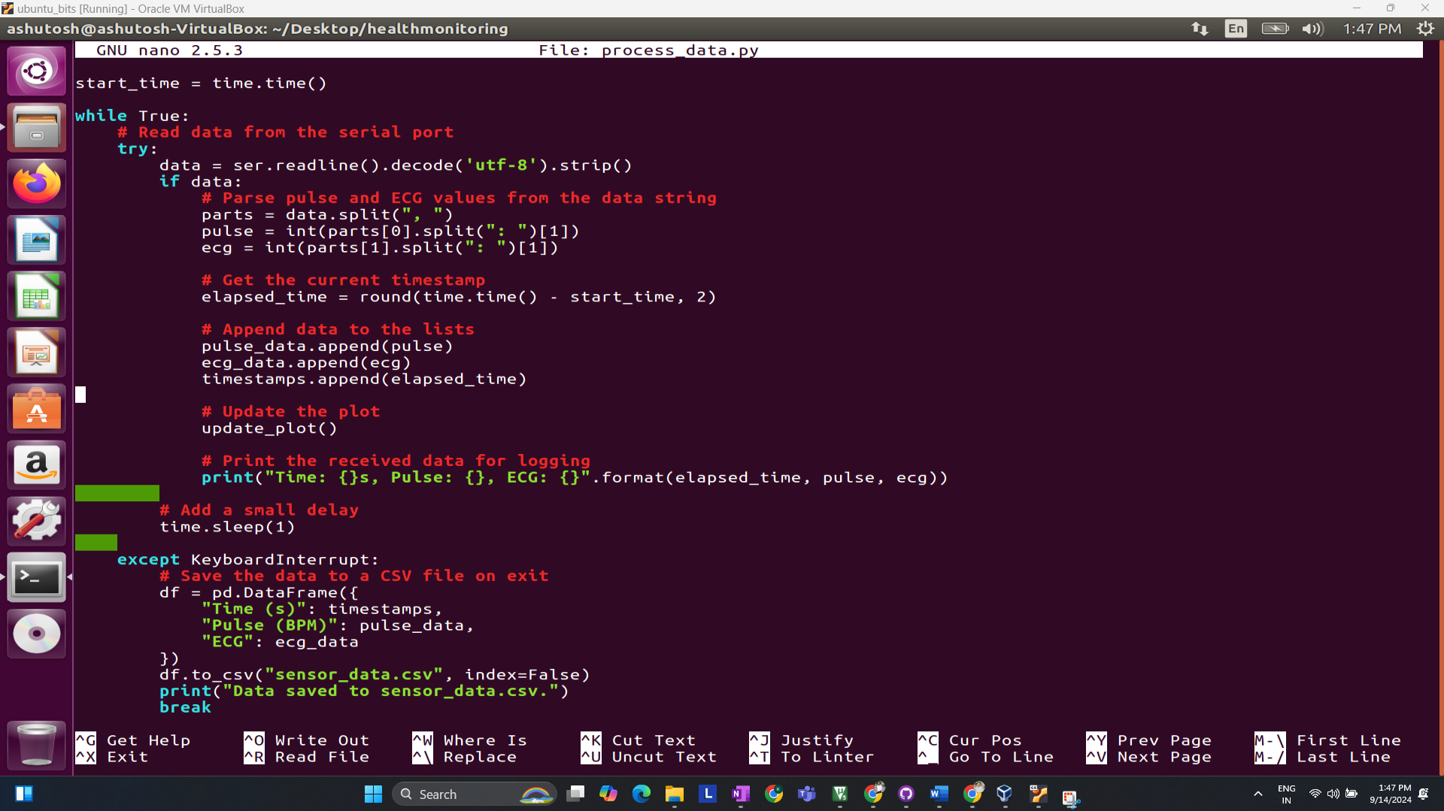

**Result:**

Real-time ECG Plot Testing…

Once the raw data is captured, you can move on to basic data processing and visualization to analyze ECG signals and detect abnormalities.

**Setting up actual sensor (ECG Sensor)**

**Pin-Configuration Block Diagram of STM32 + AD8232   
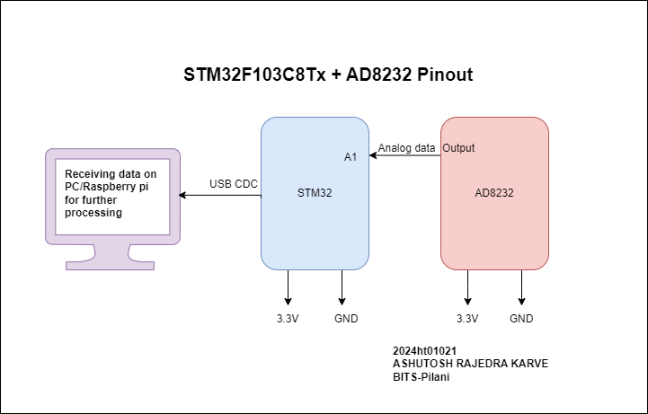  
Code//**

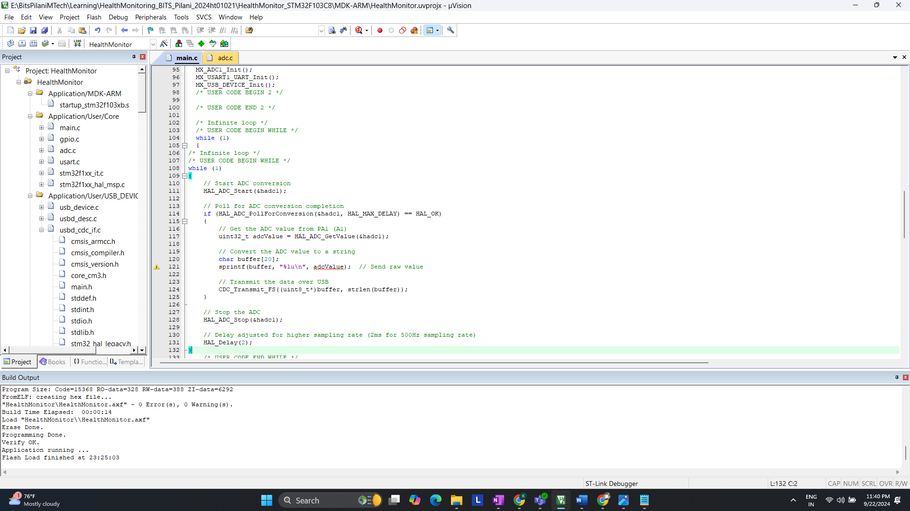

**Actual Hardware setup**

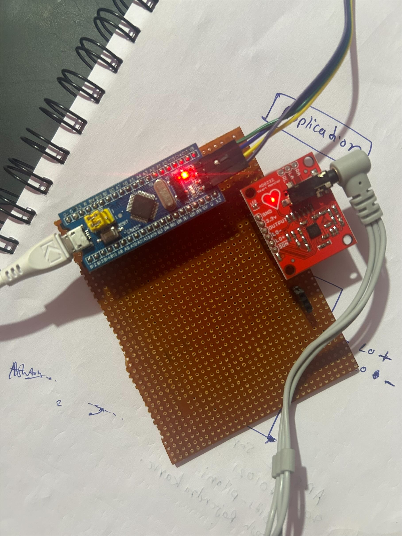

**ECG Sensor Placement on Body**

It is recommended to snap the sensor pads on the leads before sticking to the body, the closer to the heart, the better the measurement would be. The cables are color-coded to help you identify a proper placement.

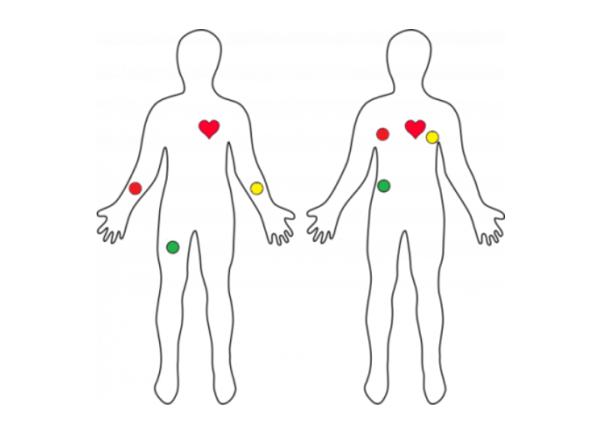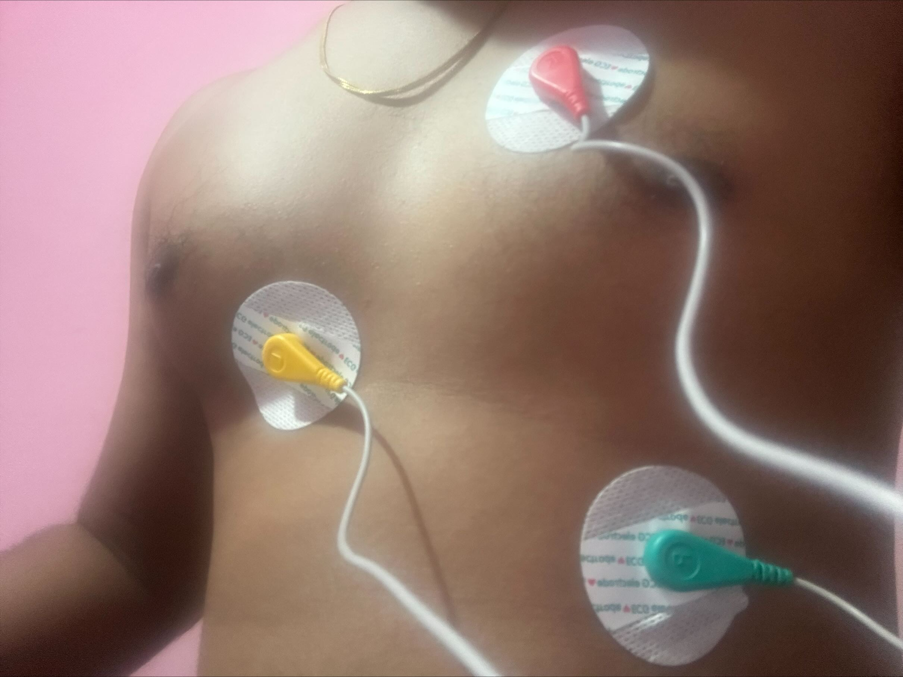

**Before moving Ahead Let’s understand what is ECG?**

ECG is the abbreviated term for an electrocardiogram. It is used to record the electrical activity of the heart from different angles to both identify and locate pathology. Electrodes are placed on different parts of a patient’s limbs and chest to record the electrical activity.

**Parts of the ECG explained**

* **P waves**

**P waves** represent **atrial depolarization**  
In healthy individuals, there should be a**P wave** preceding each **QRS** complex.

* **PR interval**

The **PR interval**begins at the**start of the** **P wave** and ends at **the beginning** of the **Q wave**.  
It **represents** the **time**for electrical activity to move**between** **the** **atria and the ventricles**.

* **QRS complex**

The **QRS complex** represents the **depolarisation of the ventricles**.  
It appears as three closely related waves on the ECG (the Q, R and S wave).

* **ST segment**

The **ST segment starts** at the **end** of the **S wave**and **ends** at the **beginning** of the**T wave**.

The **ST segment** is an isoelectric line representing the time **between** **depolarisation** and **repolarisation** of the **ventricles** (i.e. ventricular contraction).

* **T wave**

The **T wave**represents **ventricular repolarisation**.   
It appears as a small wave **after** the **QRS complex**.

* **RR interval**

The **RR interval begins** at the **peak of one R wave** & ends at the **peak of the next R wave**.  
It**represents** the **time between two QRS complexes**.

* **QT interval**

The **QT interval** begins at the start of the**QRS complex** & finishes at the end of the **T wave**.  
It **represents** the time taken for the **ventricles** to **depolarise** and then **repolarise**.

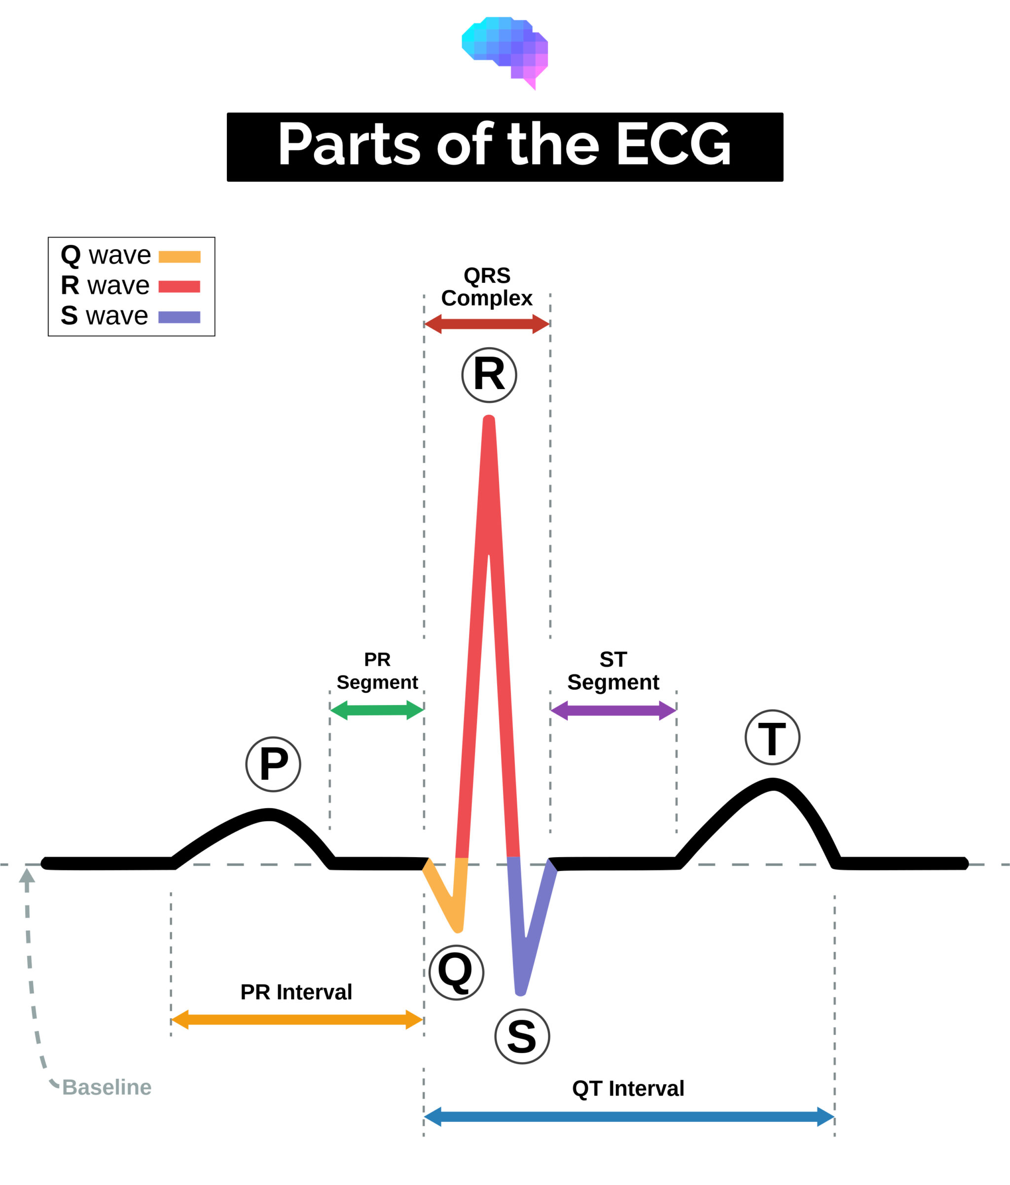

**Raw data which I am receiving on putty**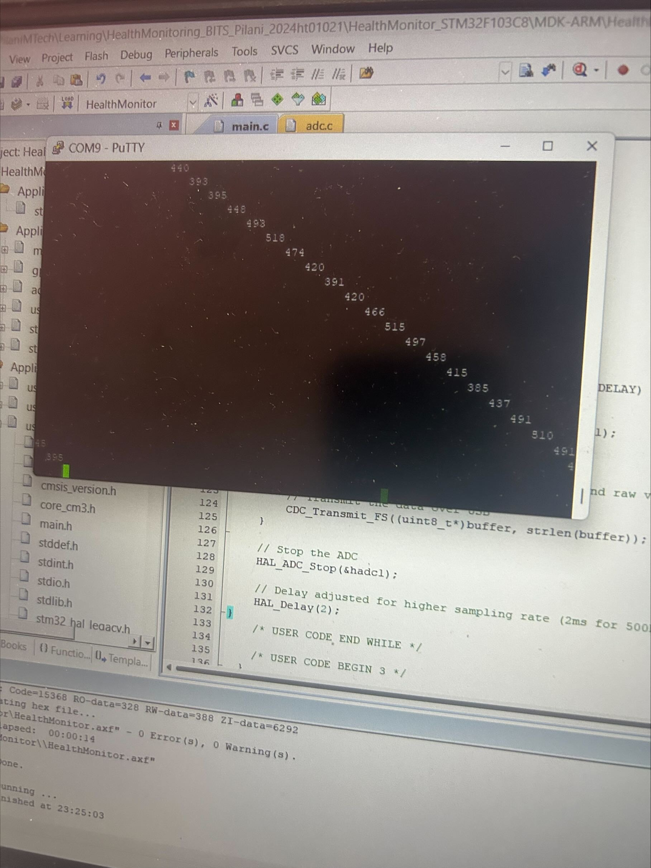

**Observations from Putty Display of ECG Data**

**Interpreting the Data:**

* Fluctuations in the range of 390–530: The readings captured in the Putty terminal indicate fluctuations between 390 and 530. These fluctuations represent various components of the ECG signal, primarily depicting the heart's electrical activity.
* QRS Complex: Values near the higher end of this range, particularly those approaching 530, are likely associated with the QRS complex, indicating ventricular contraction. This is the most prominent and critical part of an ECG trace.
* P-Wave and T-Wave: Lower values in this range, closer to 390, could potentially represent the P-wave or T-wave, which are less pronounced than the QRS complex and signify atrial depolarization and ventricular repolarization, respectively.

Periodic Patterns: The data appears to be periodically fluctuating, consistent with the expected rhythmic pattern of a normal ECG, indicating the regular beating of the heart. This rhythmic pattern is essential for analyzing cardiac function and identifying potential abnormalities.